Cable, Bus Duct, and Bus Pipe Capacity Sizing
Norbert Doerry
May 5, 2026
- Introduction
This document describes how to determine the required ampacity of cable (Figure 1), bus duct, or bus pipe (Figure 2) as well as determining the ampacity capability of a cable, bus duct or bus pipe in a particular application. For brevity, when the term “cable” in this document is used, it also applies to bus duct and bus pipe unless otherwise indicated.
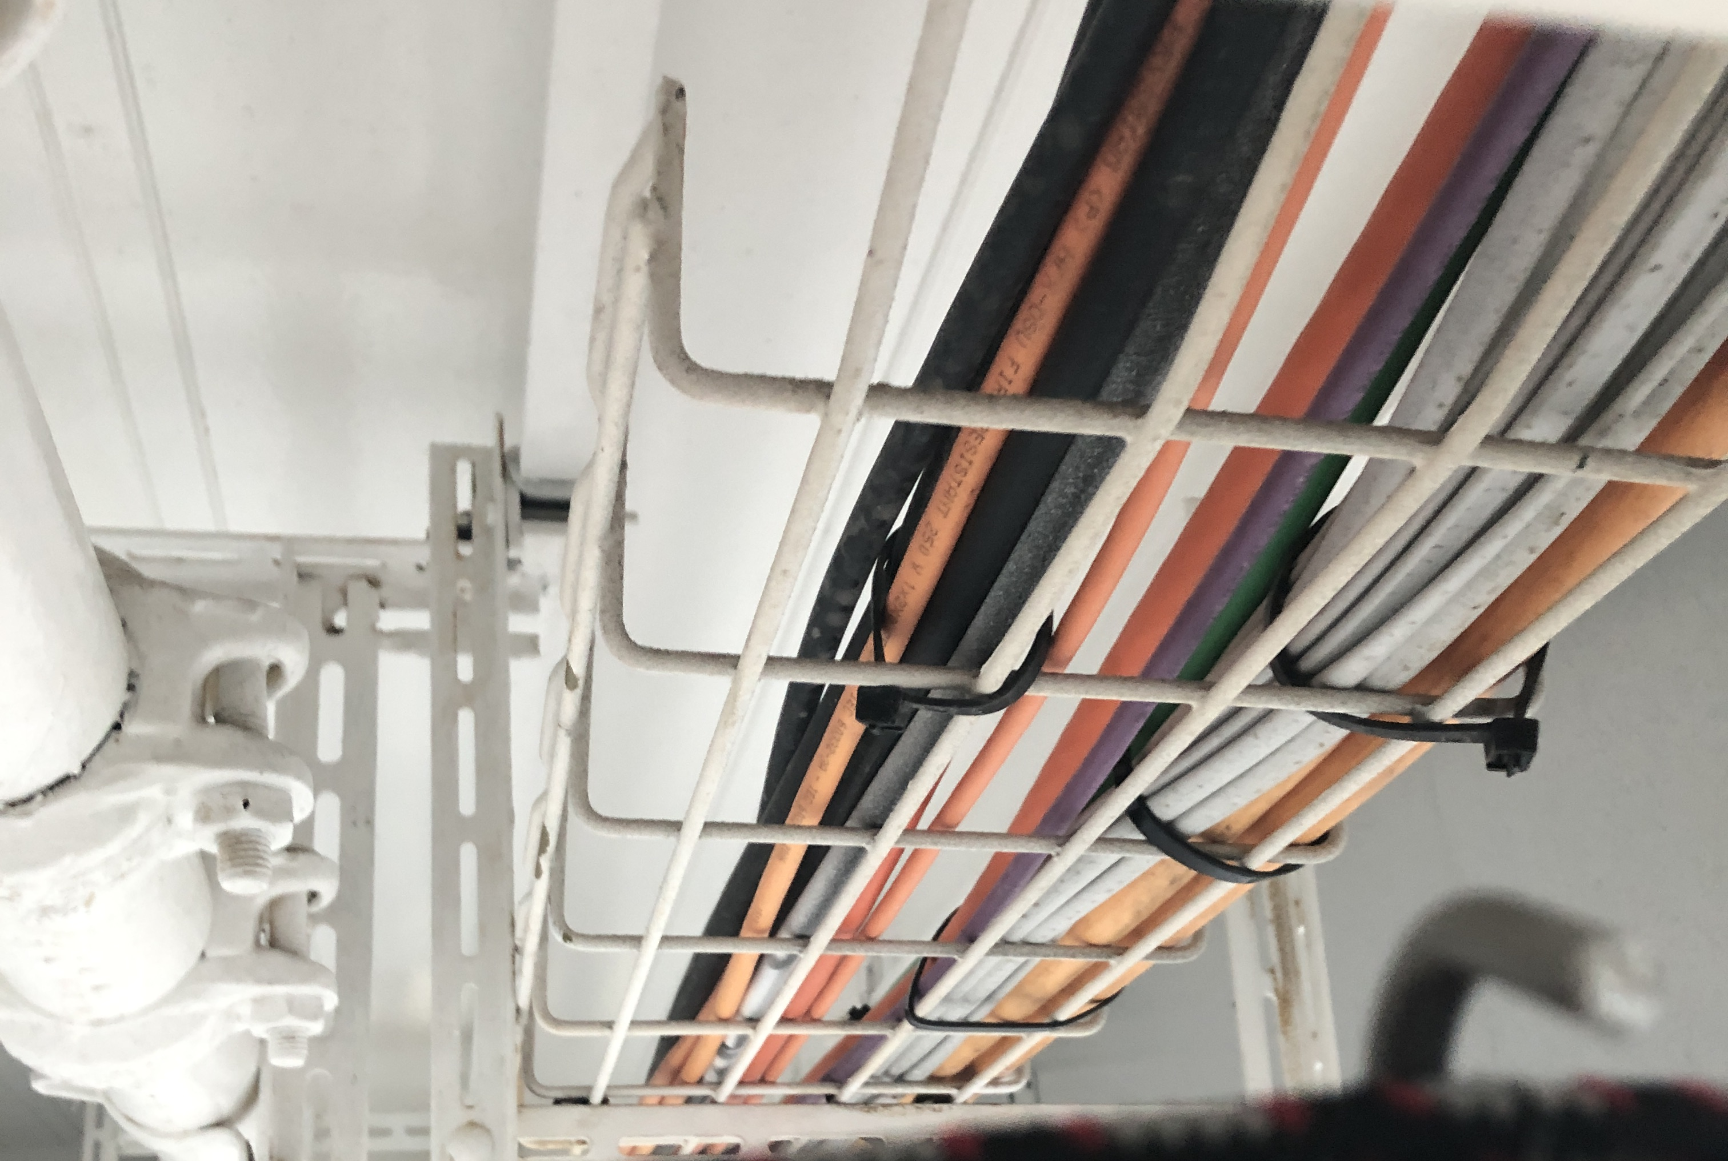
Figure 1: Cables on Emerald Princess (Photo by Norbert Doerry)
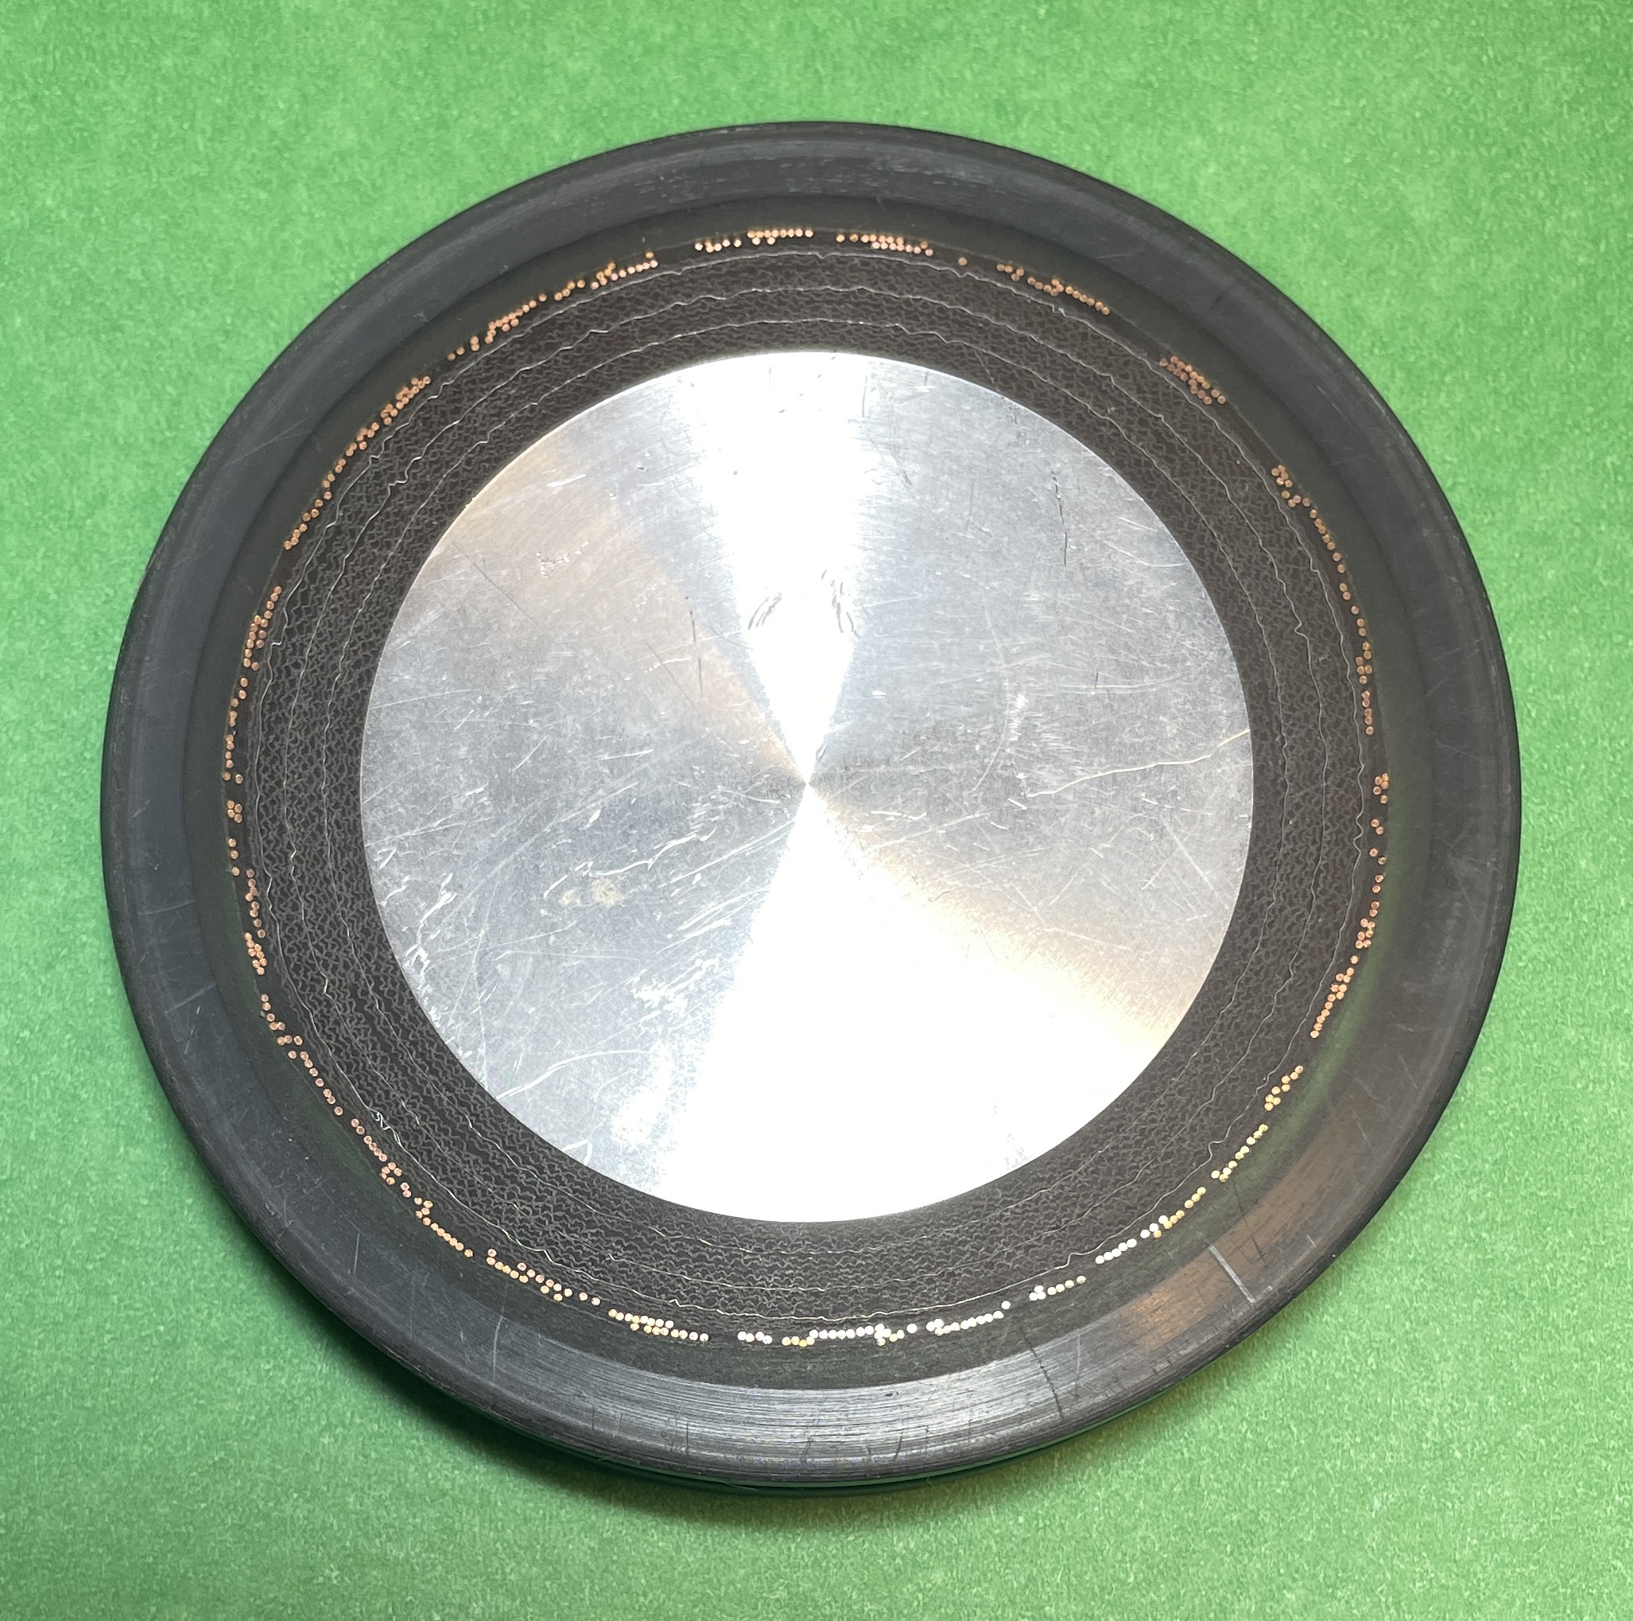
Figure 2: Insulated bus pipe cross section (Photo by Norbert Doerry)
Cable ampacity is based on limiting the temperature at the interface between the conductor surface and the insulation and on limiting the temperature at the outer surface of the cable jacket. High temperature at the interface between the conductor surface and the insulation degrades the insulation and shortens its service life; this temperature is limited to achieve the cable’s design service life. The temperature at the outer surface of the cable jacket should be cool enough to safely touch. In addition to the current flowing through the conductors, these temperatures are also a function of the ambient temperature around the cable; this ambient temperature is also influenced by the proximity of other power cables.
The resistance of a conductor increases as its temperature increases; as the current increases in a conductor, it will heat up, causing its temperature and resistance to rise, which generates even more heat and a further temperature rise. For this reason, keeping the conductor temperature within its design limits is very important.
The dc resistance (R_{DC}) of a single solid conductor is:
$$R_{DC}=\frac{ρ_{Cu}L}{A}$$
Where
$ρ_{Cu}$ = Conductor resistivity at a given temperature (ohms-cmil / ft)
L = Length of conductor (ft)
A = Conductor cross-sectional area in circular mil (cmil)
$$A=4ρ^{2}$$
$ρ$ = Conductor radius (mil) (a mil is .001 inch)
The conductor resistivity as a function of temperature T (°C) is given by:
$$ρ_{Cu}\left(T\right)=10.371\left(1+0.00393\left(T-20\right)\right)$$
This relationship can be used to adjust resistance of a conductor from one resistance (R_{T0}) at a temperature of T₀ to another (R(T)) at a temperature of T.
$$R\left(T\right)=R_{T0}\left(1+0.00393\left(T-T_{0}\right)\right)$$
MIL-HDBK-299 states that stranding will result in an approximately 2% increase in resistance.
The size of long cable conductors is also influenced by the need to limit voltage drop such that the voltage at the interface with loads remains within power interface standards.
For a cable, the minimum cable bend radius is typically about 8 times the overall cable diameter (MIL-HDBK-299). For practical applications onboard ship, this limits the overall cable diameter to about 2.5 inches. For a three-phase power cable (such as U.S. Navy type LSTSGU cable), this roughly corresponds to a conductor size of 400 MCM (thousand circular mil). If the ampacity of a cable with this diameter is insufficient, multiple cables are typically paralleled. In some cases, groups of three single conductor cables are used to allow larger phase conductors and reduce the number of labor-intensive conductor terminations. Use of single conductor cables does come at the expense of increased electromagnetic fields and the potential for electromagnetic interference.
Note that bus pipe and bus duct do not have a minimum bend radius limit and thus larger conductors may be employed. Bus pipe and bus duct may be employed to allow routing of conductors in ways that are not possible with cable.
Doerry (2020) observes:
“For the cable jacket temperature, MIL-STD-1472G establishes an exposure limit for plastic or wood of 85 °C for momentary contact and 69 °C for prolonged contact or handling.
MIL-DTL-917F states that interior shipboard equipment shall be designed to operate at an ambient temperature up to 50 °C. IEEE 45.8 lists a default ambient temperature of 45 °C.
MIL-DTL-917F indicates the maximum temperature for Cross-linked, modified polyethylene (XLPE) insulation is 125 °C for hook-up wire. Industry practice is to design for the maximum conductor temperature of 90 °C for operating temperature and 130 °C for overload temperature.
Another choice for insulation is Ethylene Propylene Rubber (EPR). Depending on formulation, it can withstand continuous temperatures up to 150 °C
MIL-HDBK-299 Table XIII indicates voltage drop calculations are based on a temperature of 65 °C. It is inferred that this corresponds to the conductor temperature.”
The maximum conductor temperature for other insulation types is provided in IEEE Std. 1580. The maximum ambient temperature for various insulation types is provided in IEEE Std 45.8.
- Required Ampacity
  - Load analysis
Cables for individual loads should be rated for the maximum current the load will draw. For cables supplying power to multiple loads, the cable should be rated for the maximum operating load.
The traditional load factor analysis process for calculating the maximum operating load assumes that the variation of load around the mean value is small; the magnitude of each cycling load is assumed small with respect to the sum of all of the load averages. While this is generally true at the total ship level, cables usually only serve a subset of the ship’s loads. Certain cycling loads may be significant; the traditional load factor analysis may underestimate the required power rating of the cable.
The zonal load factor process as described in DPC 310-1 is recommended for calculating the maximum operating load for cable if a significant amount of the load served by the cable is due to cycling loads. Zonal load factors account for the variability in the total load due to having non-constant power loads. The zonal load factor method requires for each load: the load factor for the 24-hour average calculations; the connected load; and the peak load. The zonal load factor method will generally result in a larger operating load as compared to the traditional load factor method.
For cables powering switchboards, load centers, and power panels, the maximum operating load should include the impact of loads transferred to the switchboards, load centers, and power panels due to bus transfers.
For bus-ties, load flow analysis or limiting load flow analysis as detailed by Doerry (2025a) should be employed.
  - Margin and Service Life Allowance
Margins account for uncertainty in the operating load estimate during the design and construction of a ship; service life allowance accounts for growth in load while the ship is in-service. Margins and service life allowance are applied to the maximum calculated operating load to determine the minimum required ampacity of the cable. IEEE Std. 45.1 recommends the following margins and SLA:
Detail Design Margin: 5% for existing follow-on designs to 20% for new first-time designs
Construction Margin: 5% for existing follow-on designs to 20% for new first-time designs
SLA: 20% (1% per year for 20 years)
- Ampacity
  - Rated ampacity
Reference documentation, such as manufacturer data sheets or MIL-HDBK-299, provide ampacity ratings for various cables. The ampacity is for a specific ambient temperature and assumptions as to how close the cable is mounted to other power cables.
Table I for example, is based on data from MIL-HDBK-299 and assumes the cable is physically or thermally isolated from other cables with a 50 °C ambient temperature.
IEEE Std. 45.8 provides maximum current rating for commercial marine cables.
Table I: LSTSGU Cable Properties (bold-red-italic values are estimated) (Doerry 2025b)
Type and Size | Conductor size | Ampacity  (Maximum Rated Current) (50 °C) (kA)
LSTSGU-3 | 16 AWG (Class B) | 0.010
LSTSGU-4 | 14 AWG (Class B) | 0.017
LSTSGU-9 | 10 AWG (Class B) | 0.036
LSTSGU-14 | 9 AWG (Class B) | 0.047
LSTSGU-23 | 7 AWG (Class B) | 0.064
LSTSGU-30 | Navy Standard 30 (19) | 0.073
LSTSGU-40 | 4 AWG (Class C) | 0.083
LSTSGU-50 | 3 AWG (Class C) | 0.101
LSTSGU-60 | 2 AWG (Class D) | 0.110
LSTSGU-75 | 1 AWG (Class C) | 0.136
LSTSGU-100 | 0 AWG (Class D) | 0.160
LSTSGU-125 | 00 AWG (Class D) | 0.181
LSTSGU-150 | 000 AWG (Class D) | 0.216
LSTSGU-200 | 0000 AWG (Class D) | 0.250
LSTSGU-250 | 250 MCM (Class C) | 0.282
LSTSGU-300 | 300 MCM (Class D) | 0.320
LSTSGU-350 | 350 MCM (Class D) | 0.361
LSTSGU-400 | Navy Standard 400 (127) | 0.400
  - Harmonic and common mode currents
If harmonic currents or common mode currents are present, the ampacity of a cable should be derated to account for the additional heat produced. Harmonic currents and common mode currents are generally produced by loads that employ power electronic converters. The “skin-effect” applies to high frequency components of the current; the high frequency current components concentrate at the surface of the conductor resulting in a higher effective resistance and additional heating. The cable manufacturer should be consulted to determine the required derating factor.
  - Adjustments due to ambient temperature
IEEE Std 45.8 provides tables for adjusting the ampacity of a cable based on ambient temperature for various cable types.
  - Adjustments due to installation methods
IEEE Std 45.8 describes a process for adjusting the ampacity of a cable based on installation method. Applying this process to the Maximum Rated Current values of Table I suggests using the following multipliers:
1.0 Single Banked, at least one cable diameter between adjacent cables
0.85 Single Banked, less than one cable diameter between adjacent cables
0.68 Double Banked ( = 0.85 × 0.8), two layers of cables on the same cable tray.
- Voltage drop calculations
Voltage drop calculations determine in part if a cable or set of paralleled cables powering a load has low enough impedance to ensure the voltage at the load is within power interface standard limits. Cables or sets of cables are usually sized initially on ampacity. If the cable is too long however, then the impedance will be too great and will result in an excessive voltage drop; a cable with bigger conductors, or additional cables in the set of cables may be used to achieve an acceptable voltage drop. Doerry (2025b) provides recommended practices for conducting voltage drop calculations.
- References
IEEE Std 45.1, IEEE Recommended Practice for Electrical Installations on Shipboard—Design
IEEE Std 45.8, IEEE Recommended Practice for Electrical Installations on Shipboard—Cable Systems
IEEE Std 1580, IEEE Recommended Practice for Marine Cable for Use on Shipboard and Fixed or Floating Facilities
MIL-DTL-917, Electric Power Equipment, Basic Requirements for
MIL-HDBK-299, Cable Comparison Handbook Data Pertaining to Electric Shipboard Cable
MIL-STD-1472, Design Criteria Standard, Human Engineering.
DPC 310-1 Electric Power Load Analysis (EPLA) for Surface Ships
Doerry, Norbert H., "Impedance of Four-Conductor Cable," Naval Sea Systems Command, Technology Office (SEA 05T), Ser 05T / 011 of 2 Oct 2020
Doerry, Norbert, "Shipboard power system limiting load flow and load flow analysis", IEEE ESTS 2025, Alexandria VA, August 5-8, 2025. (2025a)
Doerry, Norbert, "Voltage Drop Calculations on Shipboard Power Systems", presented at 16th International Symposium on Practical Design of Ships and Other Floating Structures PRADS 2025, Ann Arbor, MI, USA, October 19th - 23rd 2025. (2025b)

